Scott Eustis

Coastal Wetland Specialist

Gulf Restoration Network

338 baronne st NOLA 70112-1626

[scott@healthygulf.org](mailto:scott@healthygulf.org)

504 237 0323 mobile

504 525 1528 x212 office

Mathew Lippincott

PDX OR

mathew.lippincott@gmail.com

**Prospectus for Scrape of Army Corps 404 website**

There are many, many permits issued to fill and/or dredge wetlands in the New Orleans District, perhaps the most vulnerable district to wetland destruction in the United States. And many project reviewers. There may be 30 standard permits a week, and few advocates, whose time is overcommitted. There are probably more general permits issued—these are never publicly noticed. It takes a watchdog a minimum of 4 hours to review the 404 website for possible targets for comment, and 8 hours average for each comment. Each FOIA takes an hour minimum. Phone calls with regulators take 15 minutes to half an hour, usually.

Once permits “fall off the page,” a FOIA must be submitted to obtain documents that were once public. Final Decision documents almost always require a FOIA. It would be more productive to have to mail one FOIA.

Automated scrape would preserve these documents, and allow yearly review of impacts allowed by permitting. It would free up advocate time to investigate general permits hidden from public view, as well as follow up on decision documents and investigate permit violations—all of which are needed for effective watchdogging. It would assist independent review of cumulative impacts, as required of the Army Corps by rule.

Additional services like OCR and text searches within the Public Notice could streamline permit review even more. The Mississippi river Collaborative has recently proposed commenting on all permits 10 acres or more. In the New Orleans District, this will increase the work load substantially. Any time saved in permit review, finding these 10 acre permits, is time better spent fighting bad permits, and analyzing the patterns of Corps regulatory to strategically fight wetlands destruction.

Analysing and preventing wetlands destruction from the 404 process in the New Orleans District presents a challenge beyond that in most districts. But if this program is successful, it can be applied to other Army Corps Districts around the nation.

The Army Corps, by federal rule, is required to analyse permits for “Cumulative” impact of permitting, by using a “Watershed Approach.”

Holy Moly, but do they avoid doing this. They do know how, but need encouragement. Automation would assist them as well.

Such a recordkeeping / databasing/ spreadsheet-making scraper software would aid in our pressure for the Corps to regard cumulative impacts of Permits. It would also assist independent scientific review of impacts and mitigation.

Thanks for whatever assistance you can give to our efforts to protect the wetlands that protect us. Thanks for helping to keep us afloat.

For a Healthy Gulf,

Scott

WHAT WOULD AN IMAGINARY PROGRAM DO?

Task flow for Proposed scrape / data collection from Army Corps' website.

Start with New Orleans District. Public Notices for 404 are on the regulatory page.

<http://www.mvn.usace.army.mil/ops/regulatory/publicnotices.asp?ShowLocationOrder=False>

1. scrape table of Permit Numbers (every three days or every week)

[see example Excel Workbook, as well as “Cleaned” version]

each record has two files associated with it, the Public Notice ("PN") and the Drawings (dwg)

--> problem, these are always in multiple rows of the same table. highly annoying.

Figure 1 shows the hand-scraped Excel results

|  |  |  |  |  |  |  |
| --- | --- | --- | --- | --- | --- | --- |
| **Project Description** | **Applicant** | **Public Notice Date** | **Expiration Date** | **Permit** | **View or Download** | **Project Manager** |
|  |  |  |  | **Application No.** |  |  |
| Launch Boat Landing within the Mississippi River, MM 126.4 in JEFFERSON PARISH | Belle Chasse Marine Transporation, Inc. | 5/7/2012 | 6/5/2012 | MVN-2012-1000-EOO | [Public Notice](http://www.mvn.usace.army.mil/ops/regulatory/pdf/JOINT%20PUBLIC%20NOTICE_1000.pdf) | [Brad LaBorde](mailto:Brad.LaBorde@usace.army.mil) |
|  |  |  |  |  |  | 504-862-2225 |
|  |  |  |  |  | [Drawings](http://www.mvn.usace.army.mil/ops/regulatory/pdf/dwgs1000.pdf) |  |
| Construct residential subdivision in LAFAYETTE PARISH | Shivers Properties | 5/7/2012 | 5/27/2012 | MVN-2012-0894-WJJ | [Public Notice](http://www.mvn.usace.army.mil/ops/regulatory/pdf/MVN201200894.pn.pdf) | [Bobby Quebedeaux](mailto:Bobby.D.Quebedeaux@usace.army.mil) |
|  |  |  |  |  |  | 504-862-2224 |
|  |  |  |  |  | [Drawings](http://www.mvn.usace.army.mil/ops/regulatory/pdf/MVN201200894.dwg.pdf) |  |
| Modification of Ship Mooring Facility in Mississippi River in ASCENSION PARISH | Barber Bros. Contracting Co., LLC | 5/7/2012 | 6/5/2012 | MVN-1999-3891-CO | [Public Notice](http://www.mvn.usace.army.mil/ops/regulatory/pdf/JPN%2099-3891%205-7-12.pdf) | [Jamie Crowe](mailto:Jamie.M.Crowe@usace.army.mil) |
|  |  |  |  |  |  | 504-862-2675 |
|  |  |  |  |  | [Drawings](http://www.mvn.usace.army.mil/ops/regulatory/pdf/JPN%20dwgs%2099-3891%205-7-12.pdf) |  |
| Construct the Shell Island Restoration Project in PLAQUEMINES PARISH | Coastal Protection and Restoration Authority | 5/7/2012 | 6/5/2012 | MVN-2011-2935-EFF | [Public Notice](http://www.mvn.usace.army.mil/ops/regulatory/pdf/JPN.pdf) | [Darrell Barbara](mailto:Darrell.Barbara@usace.army.mil) | |
|  |  |  |  |  |  | 504-862-2260 | |
|  |  |  |  |  | [Drawings](http://www.mvn.usace.army.mil/ops/regulatory/pdf/JPN%20Plats%20.pdf) |  | |

Fig 1. Information “as scraped” contains multiple rows per record

|  |  |  |  |  |  |  |  |  |
| --- | --- | --- | --- | --- | --- | --- | --- | --- |
| **Project Description** | **Applicant** | **Public Notice Date** | **Expiration Date** | **Permit** | **Public Notice** | **Drawings** | **Project Manager Phone** | **Project Manager Email** |
|  |  |  |  |  |  |  |  |  |
| Launch Boat Landing within the Mississippi River, MM 126.4 in JEFFERSON PARISH | Belle Chasse Marine Transporation, Inc. | 5/7/2012 | 6/5/2012 | MVN-2012-1000-EOO | [Public Notice](http://www.mvn.usace.army.mil/ops/regulatory/pdf/JOINT%20PUBLIC%20NOTICE_1000.pdf) | [Drawings](http://www.mvn.usace.army.mil/ops/regulatory/pdf/dwgs1000.pdf) | 504-862-2225 | [Brad LaBorde](mailto:Brad.LaBorde@usace.army.mil) |
| Construct residential subdivision in LAFAYETTE PARISH | Shivers Properties | 5/7/2012 | 5/27/2012 | MVN-2012-0894-WJJ | [Public Notice](http://www.mvn.usace.army.mil/ops/regulatory/pdf/MVN201200894.pn.pdf) | [Drawings](http://www.mvn.usace.army.mil/ops/regulatory/pdf/MVN201200894.dwg.pdf) | 504-862-2224 | [Bobby Quebedeaux](mailto:Bobby.D.Quebedeaux@usace.army.mil) |
| Modification of Ship Mooring Facility in Mississippi River in ASCENSION PARISH | Barber Bros. Contracting Co., LLC | 5/7/2012 | 6/5/2012 | MVN-1999-3891-CO | [Public Notice](http://www.mvn.usace.army.mil/ops/regulatory/pdf/JPN%2099-3891%205-7-12.pdf) | [Drawings](http://www.mvn.usace.army.mil/ops/regulatory/pdf/JPN%20dwgs%2099-3891%205-7-12.pdf) | 504-862-2675 | [Jamie Crowe](mailto:Jamie.M.Crowe@usace.army.mil) |
| Construct the Shell Island Restoration Project in PLAQUEMINES PARISH | Coastal Protection and Restoration Authority | 5/7/2012 | 6/5/2012 | MVN-2011-2935-EFF | [Public Notice](http://www.mvn.usace.army.mil/ops/regulatory/pdf/JPN.pdf) | [Drawings](http://www.mvn.usace.army.mil/ops/regulatory/pdf/JPN%20Plats%20.pdf) | 504-862-2260 | [Darrell Barbara](mailto:Darrell.Barbara@usace.army.mil) |

Fig 2. After slight modification, One row per record. Phone number is generally in the second row per record, Links to documents are in the first and third rows per record. Records sometimes have only one or two rows, though. (links active in Microsoft documents)

1. download each file, save it with an appropriate filename, and append each one to the record associated with that Permit Number. each record is unique

--> there will be duplicates if the list is scraped every week, but sometimes permits are withdrawn, and we want to capture instances of withdrawn permits.

1. Program a chron-job to scrape the site weekly and enter records into a database, along with the date scraped. The database can also just be a spreadsheet, or exported to a spreadsheet for manipulation.

IF THIS WHERE WE HAVE TO STOP, W00T. Phase I, let’s call it. This is useful.

PHASE II --OCR the PN .pdf.

🡪most Public Notice .pdfs are posted as images. This is frustrating. Here, we should focus on the Public notice .pdf only.

There is much relevant information in the typical Public Notice. Note that the Joint Public Notice (click on 2011-2935 on previous page) is a different format.

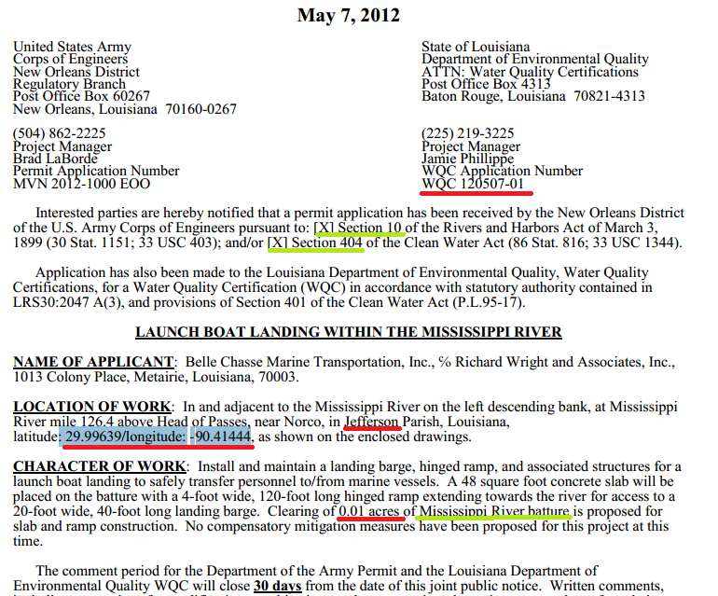

**1) extract coordinates (using the degree symbol?)**

**2) extract WQC number (and CUP number, if relevant)**

**3) extract numbers of "acres" or “acre(s)”.**

There are often multiple acreages listed, and we want them all. They are often underestimated, but they are the primary screening criteria for permit review by advocates.

There are usually two sections of acreages listed, wetland and bottom acreages, and acres of Essential Fish Habitat.

[_____acres of _______ ] “is proposed” in example above

[_____acres of EFH]

**4)Other information**

🡪 extract Parish

🡪 extract Authorities (Section 10 and Section 404)

At least for normal, non-JPN permits

--> optionally, if "mitigation bank" found, remark that.

--> optionally, if "drill" found, remark that.

--> optionally, if "road" found, remark that.

--> optionally, list numbers for "cubic yards" or "material". this is more difficult. These will be numbers estimating the volumes of material dredged or filled.

**5)Email trigger?**

sum all acreages. if sum > 10, send an email with the copy-and-pasted record, with links to files, and lists of acreages

to Scott (and Matt and Jessica of River Network, and Tulane law? Jill?)

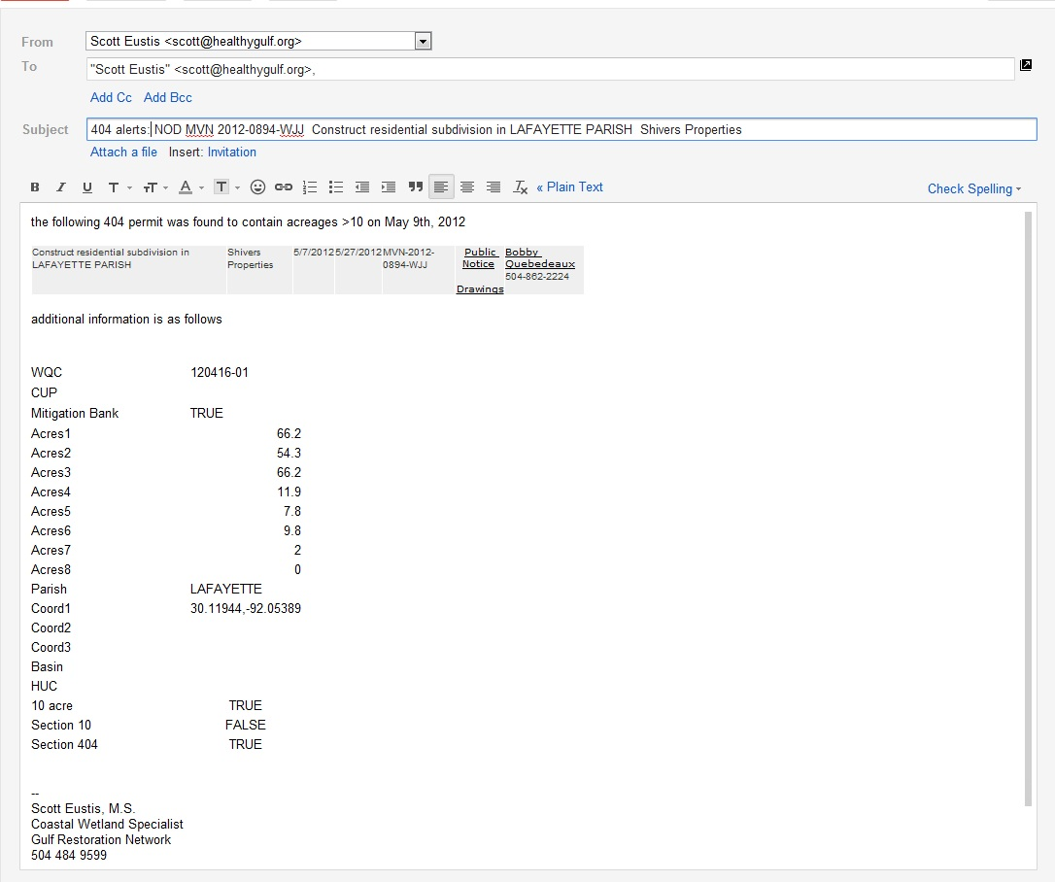

Fig. example of kind of Email, containing links to follow up upon.

Everything in Phase II is kind of a dream. See the attached Excel Sheet for an example of the kinds of data that are relevant to comments, and that we would like for cumulative analysis of permits, so that we can stop bad ones and strengthen citizen protection of our wetlands.

AND THEN

There are the Coastal Use Permits….

<http://dnr.louisiana.gov/index.cfm?md=pagebuilder&tmp=home&pid=591>

Does this dream come close to feasible? Scott